**Mandatory hands-on**

**Hands on 1**

**1.Create a Spring Web Project using Maven**

**SpringLearnApplication.java**

package com.cognizant.springlearn;

import org.slf4j.Logger;

import org.slf4j.LoggerFactory;

import org.springframework.boot.SpringApplication;

import org.springframework.boot.autoconfigure.SpringBootApplication;

*@SpringBootApplication*

public class SpringLearnApplication {

private static final Logger ***LOGGER*** = LoggerFactory.*getLogger*(SpringLearnApplication.class);

public static void main(String[] args) {

SpringApplication.*run*(SpringLearnApplication.class, args);

***LOGGER***.info("Inside main");

}

}

**Pom.xml**

<?xml version="1.0" encoding="UTF-8"?>

<project xmlns="http://maven.apache.org/POM/4.0.0" xmlns:xsi="http://www.w3.org/2001/XMLSchema-instance"

xsi:schemaLocation="http://maven.apache.org/POM/4.0.0 https://maven.apache.org/xsd/maven-4.0.0.xsd">

<modelVersion>4.0.0</modelVersion>

<parent>

<groupId>org.springframework.boot</groupId>

<artifactId>spring-boot-starter-parent</artifactId>

<version>3.5.3</version>

<relativePath/> <!-- lookup parent from repository -->

</parent>

<groupId>com.cognizant</groupId>

<artifactId>spring-learn</artifactId>

<version>0.0.1-SNAPSHOT</version>

<name>spring-learn</name>

<description>Demo project for Spring Boot</description>

<url/>

<licenses>

<license/>

</licenses>

<developers>

<developer/>

</developers>

<scm>

<connection/>

<developerConnection/>

<tag/>

<url/>

</scm>

<properties>

<java.version>17</java.version>

</properties>

<dependencies>

<dependency>

<groupId>org.springframework.boot</groupId>

<artifactId>spring-boot-starter-web</artifactId>

</dependency>

<dependency>

<groupId>org.springframework.boot</groupId>

<artifactId>spring-boot-devtools</artifactId>

<scope>runtime</scope>

<optional>true</optional>

</dependency>

<dependency>

<groupId>org.springframework.boot</groupId>

<artifactId>spring-boot-starter-test</artifactId>

<scope>test</scope>

</dependency>

</dependencies>

<build>

<plugins>

<plugin>

<groupId>org.apache.maven.plugins</groupId>

<artifactId>maven-compiler-plugin</artifactId>

<version>3.10.1</version>

<configuration>

<source>17</source>

<target>17</target>

</configuration>

</plugin>

</plugins>

</build>

</project>

**OUTPUT:**

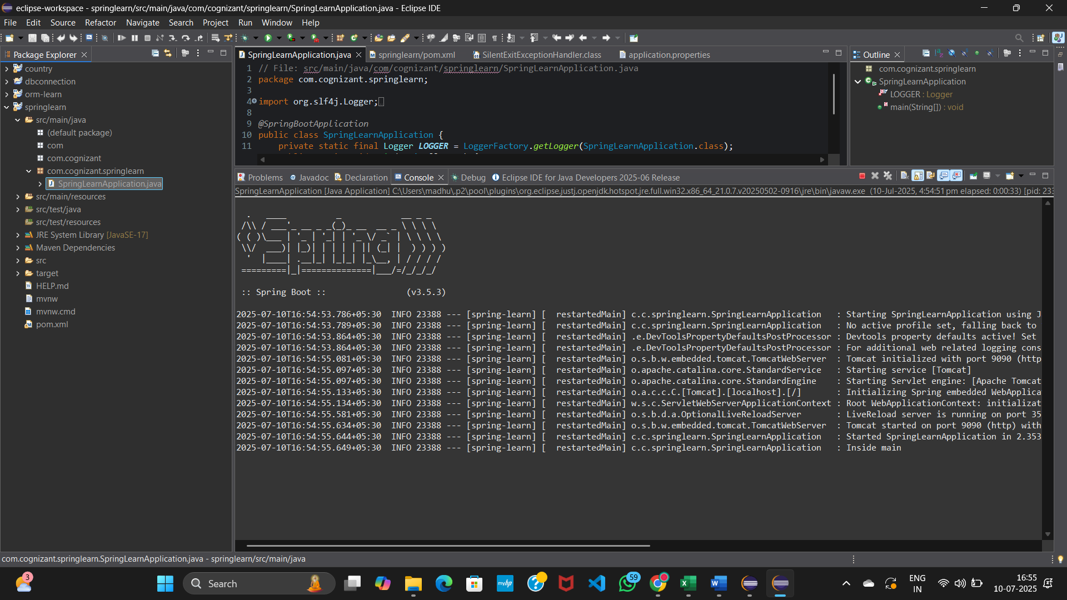

**2.Spring Core – Load Country from Spring Configuration XML**

**Country.java**

package com.cognizant.springlearn;

import org.slf4j.Logger;

import org.slf4j.LoggerFactory;

public class Country {

private static final Logger LOGGER = LoggerFactory.getLogger(Country.class);

private String code;

private String name;

public Country() {

LOGGER.debug("Inside Country Constructor");

}

public String getCode() {

LOGGER.debug("Inside getCode");

return code;}

public void setCode(String code) {

LOGGER.debug("Inside setCode");

this.code = code;

}

public String getName() {

LOGGER.debug("Inside getName");

return name;

}

public void setName(String name) {

LOGGER.debug("Inside setName");

this.name = name;

}

@Override

public String toString() {

return "Country [code=" + code + ", name=" + name + "]";

}

}

**SpringLearnApplication.java**

package com.cognizant.springlearn;

import org.slf4j.Logger;

import org.slf4j.LoggerFactory;

import org.springframework.boot.SpringApplication;

import org.springframework.boot.autoconfigure.SpringBootApplication;

import org.springframework.context.ApplicationContext;

import org.springframework.context.support.ClassPathXmlApplicationContext;

@SpringBootApplication

public class SpringLearnApplication {

private static final Logger LOGGER = LoggerFactory.getLogger(SpringLearnApplication.class);

public static void displayCountry() {

ApplicationContext context = new ClassPathXmlApplicationContext("country.xml");

Country country = context.getBean("country", Country.class);

LOGGER.debug("Country : {}", country.toString());

}

public static void main(String[] args) {

SpringApplication.run(SpringLearnApplication.class, args);

LOGGER.info("Inside main");

displayCountry();

}

}

**Country.xml**

<?xml version="1.0" encoding="UTF-8"?>

<beans xmlns="http://www.springframework.org/schema/beans"

xmlns:xsi="http://www.w3.org/2001/XMLSchema-instance"

xsi:schemaLocation="http://www.springframework.org/schema/beans

http://www.springframework.org/schema/beans/spring-beans.xsd">

<bean id="country" class="com.cognizant.springlearn.Country">

<property name="code" value="IN" />

<property name="name" value="India" />

</bean>

</beans>

**OUTPUT:**

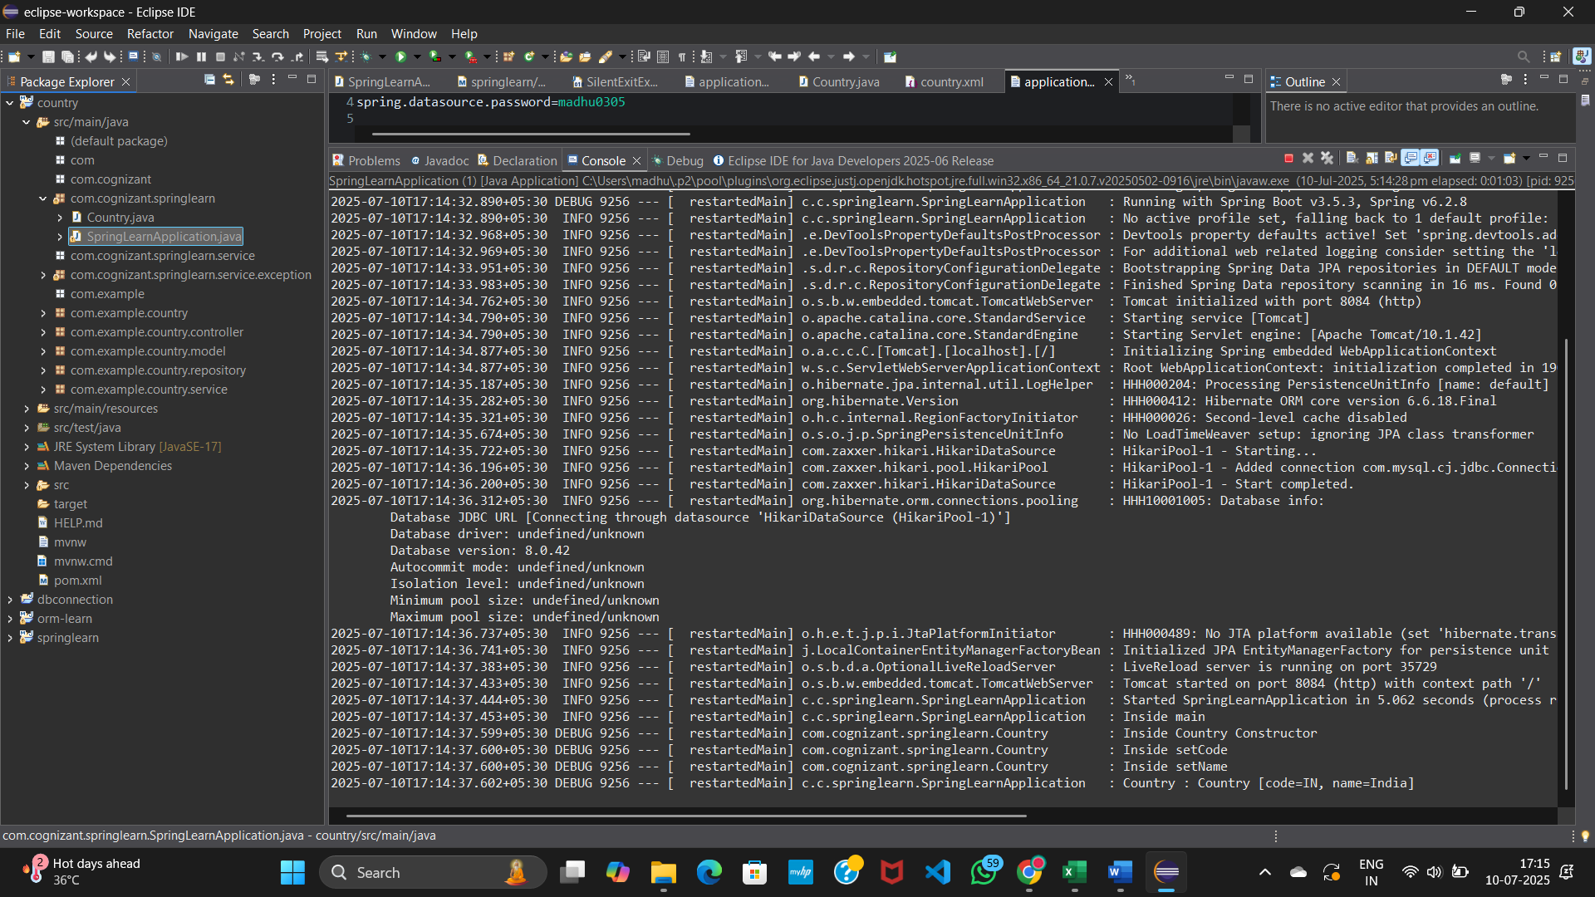

**3.Hello World RESTful Web Service**

**HelloRestServiceApplication.java**

package hellorestservice;

import org.springframework.boot.SpringApplication;

import org.springframework.boot.autoconfigure.SpringBootApplication;

@SpringBootApplication

public class HelloRestServiceApplication {

public static void main(String[] args) {

SpringApplication.run(HelloRestServiceApplication.class, args);

}

}

**HelloController.java**

package hellorestservice;

import org.slf4j.Logger;

import org.slf4j.LoggerFactory;

import org.springframework.web.bind.annotation.GetMapping;

import org.springframework.web.bind.annotation.RestController;

*@RestController*

public class HelloController {

private static final Logger ***LOGGER*** = LoggerFactory.*getLogger*(HelloController.class);

*@GetMapping*("/hello")

public String sayHello() {

***LOGGER***.info("START - sayHello()");

***LOGGER***.info("END - sayHello()");

return "Hello World!!";

}}

**OUTPUT:**

**POSTMAN:**

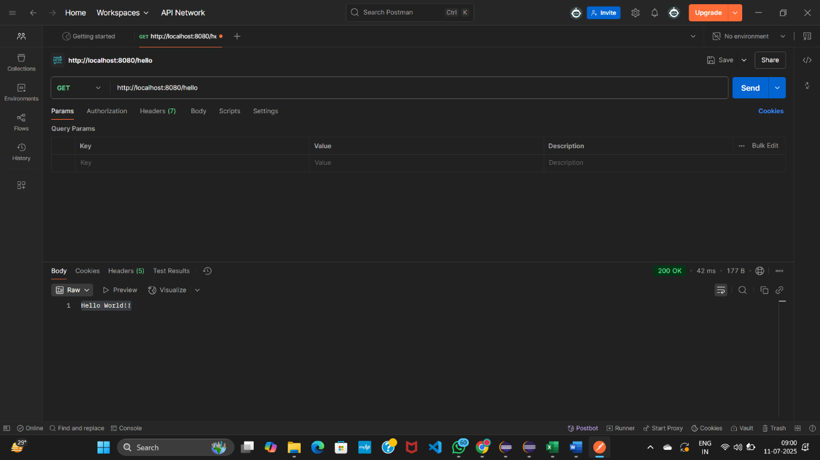

**BROWSER:**

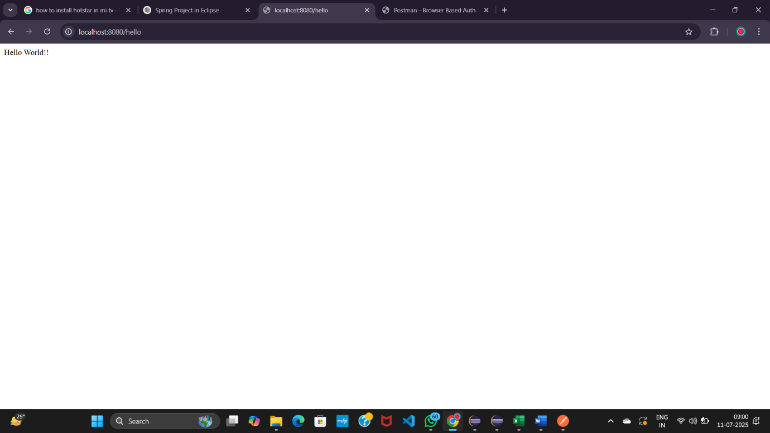

**4.REST - Country Web Service**

**Country.java**

package com.cognizant.springlearn;

import org.slf4j.Logger;

import org.slf4j.LoggerFactory;

public class Country {

private static final Logger LOGGER = LoggerFactory.getLogger(Country.class);

private String code;

private String name;

public Country() {

LOGGER.debug("Inside Country Constructor");

}

public String getCode() {

LOGGER.debug("Inside getCode");

return code;

}

public void setCode(String code) {

LOGGER.debug("Inside setCode");

this.code = code;

}

public String getName() {

LOGGER.debug("Inside getName");

return name;

}

public void setName(String name) {

LOGGER.debug("Inside setName");

this.name = name;

}

@Override

public String toString() {

return "Country [code=" + code + ", name=" + name + "]";

}

}

**SpringLearnApplication.java**

package com.cognizant.springlearn;

import org.springframework.boot.SpringApplication;

import org.springframework.boot.autoconfigure.SpringBootApplication;

*@SpringBootApplication*

public class SpringLearnApplication {

public static void main(String[] args) {

SpringApplication.*run*(SpringLearnApplication.class, args);

}

}

**CountryController.java**

package com.cognizant.springlearn.controller;

import com.cognizant.springlearn.Country;

import org.slf4j.Logger;

import org.slf4j.LoggerFactory;

import org.springframework.context.ApplicationContext;

import org.springframework.context.support.ClassPathXmlApplicationContext;

import org.springframework.web.bind.annotation.RequestMapping;

import org.springframework.web.bind.annotation.RestController;

*@RestController*

public class CountryController {

private static final Logger ***LOGGER*** = LoggerFactory.*getLogger*(CountryController.class);

*@RequestMapping*("/country")

public Country getCountryIndia() {

***LOGGER***.info("START getCountryIndia");

ApplicationContext context = new ClassPathXmlApplicationContext("country.xml");

Country country = (Country) context.getBean("country", Country.class);

***LOGGER***.info("END getCountryIndia");

return country;

}

}

**OUTPUT:**

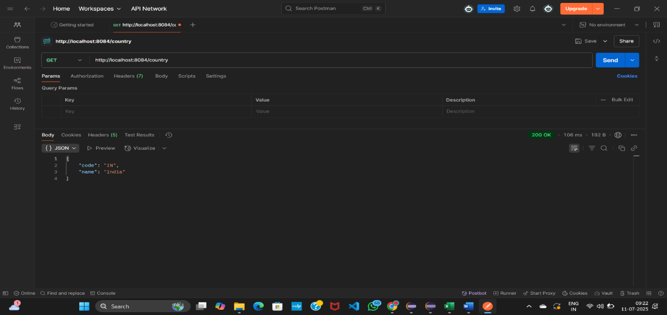

**5.REST - Get country based on country code**

**SpringLearnapplication.java**package com.cognizant.springlearn;

import org.springframework.boot.SpringApplication;

import org.springframework.boot.autoconfigure.SpringBootApplication;

*@SpringBootApplication*(scanBasePackages = "com.cognizant.springlearn")

public class SpringLearnApplication {

public static void main(String[] args) {

SpringApplication.*run*(SpringLearnApplication.class, args);

}

}

**CountryController.java**

package com.cognizant.springlearn.controller;

import com.cognizant.springlearn.Country;

import com.cognizant.springlearn.service.CountryService;

import org.springframework.web.bind.annotation.*;

*@RestController*

*@RequestMapping*("/countries") // <== very important

public class CountryController {

private final CountryService countryService;

public CountryController(CountryService countryService) {

this.countryService = countryService;

}

*@GetMapping*("/{code}")

public Country getCountry(*@PathVariable* String code) {

return countryService.getCountry(code);

}

}

**Country.xml**

<?xml version="1.0" encoding="UTF-8"?>

<beans xmlns="http://www.springframework.org/schema/beans"

xmlns:xsi="http://www.w3.org/2001/XMLSchema-instance"

xsi:schemaLocation="http://www.springframework.org/schema/beans

https://www.springframework.org/schema/beans/spring-beans.xsd">

<bean id="in" class="com.cognizant.springlearn.Country">

<property name="code" value="IN" />

<property name="name" value="India" />

</bean>

<bean id="countryList" class="java.util.ArrayList">

<constructor-arg>

<list>

<ref bean="in" />

<!-- Add more countries here if needed -->

</list>

</constructor-arg>

</bean>

</beans>

**CountryService.java**

package com.cognizant.springlearn.service;

import java.util.List;

import org.springframework.context.ApplicationContext;

import org.springframework.context.support.ClassPathXmlApplicationContext;

import org.springframework.stereotype.Service;

import com.cognizant.springlearn.Country;

*@Service*

public class CountryService {

public Country getCountry(String code) {

ApplicationContext context = new ClassPathXmlApplicationContext("country.xml");

List<Country> countryList = (List<Country>) context.getBean("countryList");

return countryList.stream()

.filter(c -> c.getCode().equalsIgnoreCase(code))

.findFirst()

.orElse(null);

}

}

**Country.java**

package com.cognizant.springlearn.model;

public class Country {

private String code;

private String name;

public Country() {

System.***out***.println("Inside Country Constructor");

}

public String getCode() {

System.***out***.println("Getter for code");

return code;

}

public void setCode(String code) {

System.***out***.println("Setter for code");

this.code = code;

}

public String getName() {

System.***out***.println("Getter for name");

return name;

}

public void setName(String name) {

System.***out***.println("Setter for name");

this.name = name;

}

*@Override*

public String toString() {

return "Country [code=" + code + ", name=" + name + "]";

}

}

**OUTPUT:**

